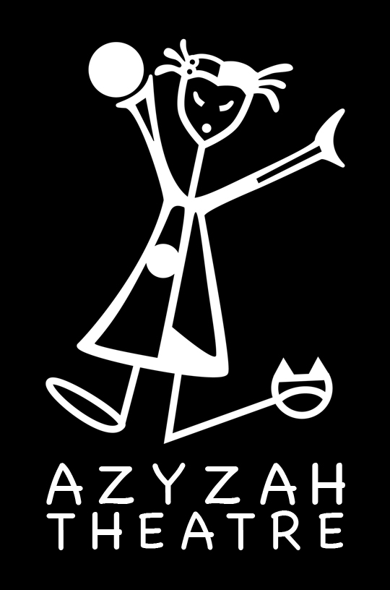

Azyzah Theatre
English Educational Theatre

Travel Machine * Student/Teacher Material
Exercises for students (before the performance)

This Student / Teacher Pack contains lesson plans related to the interactive performance of the Travel Machine.
All lessons are a supplement to the show for year 4 & 5 and may be adapted to each level as teachers see fit.

Azyzah Theatre may be contacted for guidance related to all lessons.

Contact:
Vanessa Gendron ( Director, Creator)
tel. (+420) 608 454 655
email. Vanessa@azyzah.com
www.azyzah.com

FOCUS

We focus on giving the students a chance to understand the basic story of the Travel Machine show.

Supporting materials are:

-Review of the map of the world (continents, countries, animals)
-Worksheets
-English songs
-Communicative English (greetings, asking simple questions)

TOPIC 1 – Comprehension

Tell the children the basic story outline of the Travel Machine.

In this SHOW you will meet Mr. Suits, a crazy scientist who built a TRAVEL MACHINE and his assistant Kiki who has the power to communicate to animals. They will travel around the world to find new friends to join their dance party.

During this adventure the students will be travelling around the world visiting the seven continents with Mr. Suits and Kiki. They will make new friends, sing and answer questions.

TOPIC 2– Vocabulary – Map of the World

This is a good opportunity to review the map of the world in English by looking at the 7 continents (North America, South America, Asia, Europe, Africa, Oceania/Australia, Antarctica).

Ask the students to name the seven continents in English by showing each one on a large map.

Ask students which countries they have visited.

In a discussion ask which animals live on each continent.

Make this list of animals on the board with the children.

Have the students write the 7 continents in English and draw 2-3 animals that live in each continent from your discussion list* You may print worksheet 2 or have the students draw their own map.

Here is a basic list:

North America (polar bear, fox, cow, horse)
South America (crocodile, snakes, parrot)
Asia (panda, tiger, elephant, giraffe, camel)
Europe (rabbit, elk, dogs, dinosaurs)
Africa (monkey, zebra, lion, cat)
Oceania/Australia (shark, kangaroo, dingo)
Antarctica (polar bear, seal, whale, penguin)

Travel Machine WORKSHEET 1

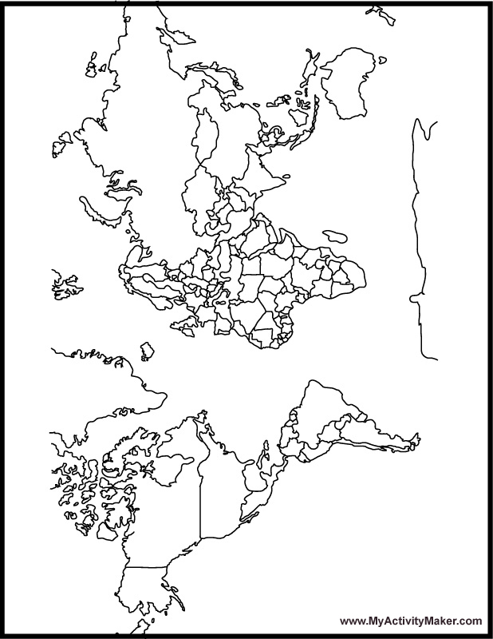

Travel Machine WORKSHEET 2

Make 7 sentences with the following words and match each word to its proper group.
Example: The shark lives in Australia on the Oceania continent.

Kangaroo Brazil North America

Crocodile Czech Republic Asia

Horse Egypt South America

Dinosaur Delphia Europe

Whale Texas Africa

Dragon China Oceania/Australia

Cat Sydney Antarctica

1-________________________________________________________________
2-________________________________________________________________

3-________________________________________________________________

4-________________________________________________________________

5-________________________________________________________________

6-________________________________________________________________

7-________________________________________________________________

TOPIC 3 – English Songs
(We suggest you do this activity after the performance)

Practice these songs with the children in class and have them draw the animal represented in each song.

BINGO the Dinosaur
There was a whale so enormous and BINGO was his name-o. B-I-N-G-O B-I-N-G-O B-I-N-G-O And Bingo was his name-o.
There was a whale so enormous and BINGO was his name-o. (clap)-I-N-G-O (clap)-I-N-G-O (clap)-I-N-G-O And Bingo was his name-o.
There was a whale so enormous and BINGO was his name-o. (clap)-(clap)-N-G-O (clap)-(clap)-N-G-O (clap)-(clap)-N-G-O And Bingo was his name-o.
There was a whale so enormous and BINGO was his name-o. (clap)-(clap)-(clap)-G-O (clap)-(clap)-(clap)-G-O (clap)-(clap)-(clap)-G-O And Bingo was his name-o.
There was a whale so enormous and BINGO was his name-o.. (clap)-(clap)-(clap)-(clap)-O (clap)-(clap)-(clap)-(clap)-O (clap)-(clap)-(clap)-(clap)-O And Bingo was his name-o.
There was a whale so enormous and BINGO was his name-o. (clap)-(clap)-(clap)-(clap)-(clap) (clap)-(clap)-(clap)-(clap)-(clap) (clap)-(clap)-(clap)-(clap)-(clap) And Bingo was his name-o.

What’s your Name
What’s your name?
What’s your name won’t you tell me?
Her/his name is…Julie…
Julie is the name for her.

TOPIC 4 - Greetings *Hi! My name is ……

Have the children make a finger puppet. Templates can be downloaded from this site http://www.enchantedlearning.com/crafts/puppets/twofinger/l

*OR You can have the students draw their own finger puppet on a cardboard paper, colour and cut it out.

Examples:

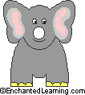

Once their puppets are ready. They must practice the following phrases. Introduce themselves in front of the class than circulate and talk with the others.

Hi! My name is ________________.

I come from the Czech Republic.

That is in Europe.

I am 7 years old.

My favourite animal is the crocodile that lives in South America.

Topic 5 – Asking questions
*Would you like to come with us?

Using their made puppets have the children travel in an imaginary machine and ask each other if they would like to come with us…

To different places – have them say several places that they have learnt in previous lessons.

They can use the map for help.

1-Would you like to come with us on our travel machine? We are going to…

Examples:

Brazil in South America
Texas in North America
The Czech Republic in Europe
China in Asia
Egypt in Africa
Delphia in Antarctica
Sydney in Australia

2-Once they land in one place they meet a puppet animal and ask them simple questions like. You can also divide the class in two some travelling and some animals. The travelling students write down the answers to the following questions.

How are you?

What is your favourite colour?

What is your favourite food?

Do you like to dance?

