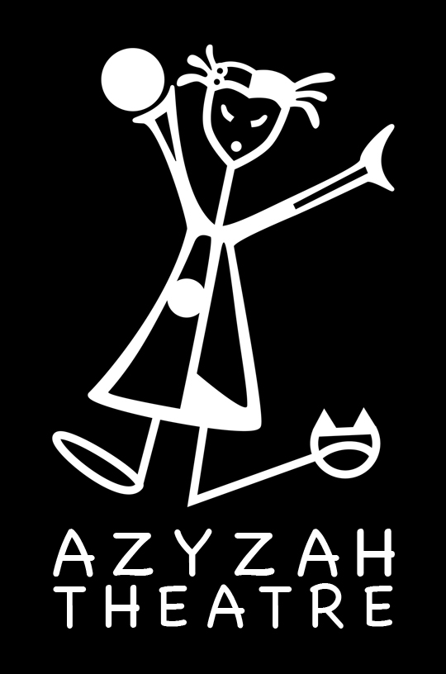

Azyzah Theatre
English Educational Theatre

Lost in the Land of Twirls* Student/Teacher Material
Exercises for students (before the performance)

This Student / Teacher Pack contains lesson plans related to the interactive show Lost in the Land of Twirls.

All lessons are a supplement to the show for preschool to year 3 and may be adapted to each level as teachers see fit.

Azyzah Theatre may be contacted for guidance related to all lessons.

Contact:
Vanessa Gendron ( Director, Creator)
tel. (+420) 608 454 655
email. Vanessa@azyzah.com
www.azyzah.com

FOCUS
Students will learn a multiple of new English songs with the help of the Lost in the Land of Twirls Link.

Supporting materials are:

-Worksheets
-Interactive game where we explore each song
-Communicative English

TOPIC 1 Comprehension

Tell the children the basic story outline of the Lost in the Land of Twirls.

In this SHOW you will meet Kiki in a unique adventure where she finds herself lost in the land of Twirls where everything is possible.
She will need the students to visit each place on the map, succeed at a task and get a word clue. Once, she will have all the clues she will have to answer the final question correctly in order to go home.
Most songs are related to the characters Kiki will meet with the students.

Get ready for surprises when we meet:

-The ant (song and task)
- A laughing lady (task)
-A monkey (song and task)
-The rhythmical Guru ( task)
-Little Bunny Foo foo ( task)
-A drop ( task)
-A sun (song)

TOPIC 2 – Song Lyrics

Learning a language is particularly encouraging when you can sing to it. Students love to sing. Singing with movement helps to discover the meaning of each word and the message of the entire song. Learn new songs while listening to our CD.

1) The ants go marching

The ants go marching one by one
Hurrah, hurrah.
The ants go marching one by one
Hurrah, hurrah.
The ants go marching one by one,
The little one stop to talk on the phone [or: to suck his thumb.]
And they all go marching down
Around the town [or: to the ground, to get out of the rain.]
Boom, boom, boom, boom.

One…sucks his thumb
Two…tie her shoe…
Three…because pipi…
Four… shut the door… [Or: shut the door…]

2) I’m Lost
I’m lost, I’m lost,( stand ) I’m lost , I’m lost I’m lost (walk DSL)– no time to say hello good bye
I’m lost, I’m lost, I’m lost, (3x)

3) Looking for our way home
We’re not afraid
Look, what’s up ahead?

A Lake!
Can't go over it.
Can't go under it.
Can't go around it.
Got to go row through it.

Everybody get on your boat – 1-2-3. Show me your arms…

4) Oh, Mr. Sun, Sun, Mr. Golden Sun,
Please shine down on me.
Oh Mr. Sun, Sun, Mr. Golden Sun,
Hiding behind a tree

These children are asking you
To please come out so we can play with you.
Oh Mr. Sun, Sun, Mr. Golden Sun,
Please shine down on,
please shine down on,
Please shine down on me.

WORKSHEET 1

Mister Sun

Directions: Fill in the spaces by using the words from the word bank.

Sun down sun down

Tree you play shine

Oh Mr. Sun, Sun, Mr. Golden ……………….,

Please shine ……………… on me.
Oh Mr. Sun, ……………. Mr. Golden Sun,

Hiding behind a …………….
These little children are asking ………….
To please come out so we can …………… with you.
Oh Mr. Sun, Sun, Mr. Golden Sun,
Please shine …………… on,
Please shine down on,
Please. Down on me.

TOPIC 3 - Interactive Communication
Learning English through movement and song

1-Teach the songs to the students.

*Create movement that match in the action to each song and explain the story of each song.

2- Interactive game

a) In groups have them act out each song with movement.

b) Have them retell the story of the song without singing it and act it out.

